

YEAR: 11

SUBJECT: Human Biology Year 11 Units 1 and 2

TEST: Digestion and Urinary System Test
TIME: 60 minutes
QUESTIONS: 20 Multiple Choice, 6 Short Answer, 1 Extended Answer
TOTAL MARKS: 70

DO NOT WRITE ON OR MARK THIS PAPER

SECTION ONE—MULTIPLE CHOICE (20 marks)

This section has 20 questions. Answer all questions on the separate Multiple-choice Answer Sheet provided.

Question 1
When proteins have been completely digested and are ready for absorption they are in the form of:
- glucose
- fatty acids
- amino acids
- glycerol

Question 2
Food is moved through the alimentary canal by a muscular action known as:
- metabolism
- peristalsis
- elimination
- defecation

Question 3
Hydrochloric acid in the stomach:
- is a symptom of a digestive disorder
- is a digestive enzyme which hydrolyses fat
- assists in the digestion of starch
- makes the stomach more acidic to allows enzymes to act

Question 4
The teeth used for biting and cutting of food are:
- premolars
- molars
- incisors
- canines

Question 5
The part of the digestive tract where absorption of water and vitamins occurs is the:
- large intestine
- small intestine
- stomach
- pancreas

Question 6
Chemical digestion of starch:
- begins in the stomach and continues until the large intestine
- occurs at all points along the digestive tract
- takes place mainly in the large intestine
- begins in the mouth and involves salivary amylase
Question 7
Which of the following is involved in mechanical digestion in the small intestine:
- bile salts
- amylase
- protease
- lipase

Question 8
Lipids are broken down:
- by bile, an enzyme that is produced in the liver
- in the small intestine, by amylase, into fatty acids and glycerol
- in the small intestine, by lipase and absorbed into the lacteals
- in the gall bladder, by lipase, and transported to the small intestine

Question 9
The process of faecal matter (non-metabolic waste) being removed from the body is the process of:
- excretion
- active transport
- diffusion
- elimination

Question 10
After digestion and absorption in the villi of the small intestine, which one of the following nutrients would enter the blood stream via the lymphatic system at the thoracic duct?
- Sugar
- Amino Acids
- Lipids
- Vitamins

Question 11
The correct order of the major processes occurring in the kidneys is:
- glomerular filtration, selective reabsorption, tubular secretion
- selective reabsorption, tubular secretion, glomerular filtration
- tubular secretion, selective reabsorption, glomerular filtration
- glomerular filtration, tubular secretion, selective reabsorption

Question 12
Which of the following organs is NOT involved in excretion of wastes?
- lungs
- stomach
- kidneys
- sweat glands in the skin

Question 13
The kidneys remove nitrogenous wastes from the body. Choose the correct list of these wastes:
- water, urea and bile
- uric acid, urea and salt
- urea, creatinine and salt
- urea, uric acid and creatinine

Question 14
Like many organs of the body the structure of the kidney is directly related to its function. Each kidney has over a million nephrons, why is this important for the processes of reabsorption and secretion?
- decreases surface area, allowing for efficient reabsorption and secretion.
- allows more time for the processes to occur
- increases surface area, allowing for efficient reabsorption and secretion.
- only a certain number of nephrons can undertake either process

Question 15
Large proteins are not normally found in the urine because they:
- are broken down into amino acids by the kidneys
- are too large to be filtered by the kidneys
- are needed by the body for energy
- do not exist in the blood, only amino acids are present in the blood.

Question 16
Approximately 1.5L of urine is passed each day by a healthy person. Which of the following could be cause for concern in regards to urine passed?
- the urine is around 99% water
- the urine contains glucose
- the urine has a pale yellow colour
- the urine does not contain significant amounts of protein

Question 17
The first step in the process of urine formation is glomerular filtration. Fluid is forced out of the capillaries because of:
- the high pressure of blood in the glomerulus
- the active transport of water
- the low pressure of blood in the glomerulus
- the diffusion of water

Question 18
Urine is slightly acidic because of the presence of hydrogen and ammonium ions in the filtrate. The normal pH of urine is considered to be:
- pH9
- pH6
- pH13
- pH7

Question 19
In order to help maintain healthy kidneys it is advised that certain lifestyle habits are avoided. Which of the following is NOT a habit that should be avoided in this case?
- smoking
- excessive alcohol consumption
- being overweight
- drinking water rather than drinks containing sugar

Question 20
The bladder’s main function is to:
- absorb some vitamins
- reabsorb water from urine
- reabsorb mineral ions from urine
- store urine before it is removed from the body

Digestive and Urinary System Test:
ANSWER BOOKLET

NAME:
FORM: DATE:

Multiple Choice Short Answer Extended Answer Total

/20

/40

/10

/70

SECTION ONE: Multiple choice answers
Cross (X) through the correct answer.

1 | a | b | c | d |  | 11 | a | b | c | d
2 | a | b | c | d |  | 12 | a | b | c | d
3 | a | b | c | d |  | 13 | a | b | c | d
4 | a | b | c | d |  | 14 | a | b | c | d
5 | a | b | c | d |  | 15 | a | b | c | d
6 | a | b | c | d |  | 16 | a | b | c | d
7 | a | b | c | d |  | 17 | a | b | c | d
8 | a | b | c | d |  | 18 | a | b | c | d
9 | a | b | c | d |  | 19 | a | b | c | d
10 | a | b | c | d |  | 20 | a | b | c | d

SECTION TWO – SHORT ANSWER
Six questions worth 40 marks
Complete all answers in wither blue or black pen.

Question 21

- What is the name of the structure shown in the diagram below? (1 mark)

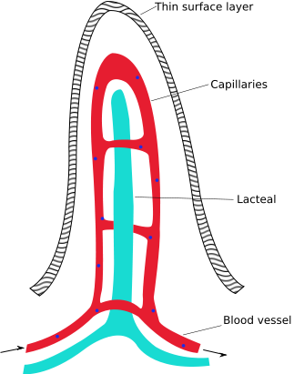

- What is the main function of this structure? (1 marks)

- Explain how lipids enter this structure? (2 marks)

Question 22
Label the following diagram of the kidney (6 marks)
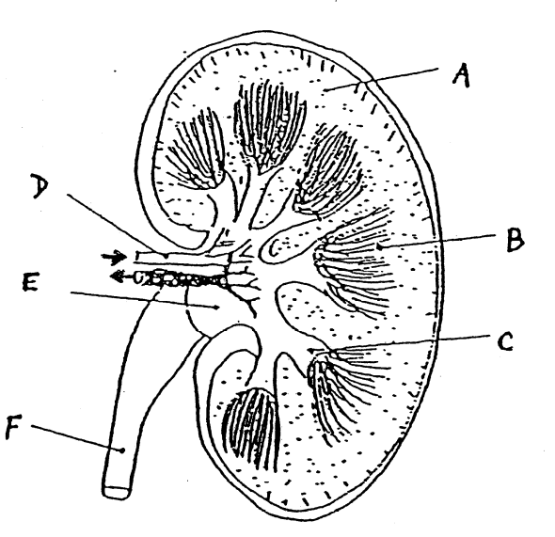

Label | Structure
A
B
C
D
E
F

Question 23
Ammonia is a toxic waste product that is produced by normal processes in the human body.
- Explain how ammonia comes to be present in the body (2 marks)

- How is ammonia removed from the body? (2 marks)

Question 24
- Label the following diagram of the digestive system (8 marks)
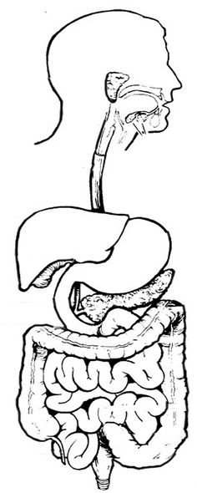

Label | Structure
A
B
C
D
E
F
G
H

- What is the name of the sphincter that controls movement of substances between the stomach and small intestine? (1 mark)

Question 25
a) What is meant by the following terms:
- Glomerular filtration? (2 marks)

- Selective Reabsorption? (2 marks)

- Tubular Secretion? (2 mark)

b) If glucose is found in the urine, what explanations could be given for this observation? (2 marks)

Question 26
Complete the following table by giving three examples of large surface areas in the digestive and/or urinary system and how the large surface area of each example assists with its function.
(9 marks)
 | (a) example of large surface area | (b) assists with its function (At least 2 answers for each example)
(i)
(ii)
(iii)
SECTION THREE – EXTENDED ANSWER
One question worth 10 marks
Answer question using blue or black pen and pencil for the diagrams.

Question 27
For breakfast you have a fried egg on toast. Discuss the fate of your breakfast from the time it enters your body until it is absorbed or eliminated from your body.
In your discussion you should mention;
- The food nutrient groups present. (1 mark)
- The regions of the alimentary canal it passes through and their functions. (4 marks)
- The digestive enzymes involved and what they act upon. (4 marks)
- The final products. (1 mark)

END OF TEST

